

**ENGLISH**

English listening activity

**MEMBERS:**

Laura Carolina Pérez- cc 1128398243

María Camila cuartas chica - cc 1040755329

Alexandra Parra Bedoya -cc 1152689335

Cristian Santiago Arango Osorio – cc 1001250382

María Alejandra Marín Velásquez cc 1128481980

**TEACHER:**

Pablo Andrés Aristizábal Uribe

**INSTITUCIÓN UNIVERSITARIA ESUMER**

Medellín

2024

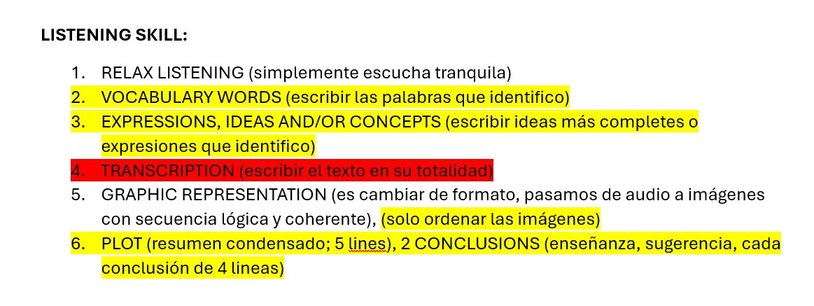

2 **Vocabulary words**

**Cheap**: Barato

**Bought**: Comprado

**Market**: Mercado

**Box**: Caja

**Anyway**: De todos modos

**Suddenly**: De repente

**Leave**: Salir

**Bags**: Bolsas

**Return to:** Regresar

**Things**: Cosas

**Picked up**: Recogido

**Angry**: Enfadado

**Paid**: Pagado

**Luggage: Equipaje**

**Enough:** Suficiente

**There:** Allí

**Access:** Acceso

**Airport:** Aeropuerto

**Package:** Paquete

**Told:** Dijo

**Became:** Se convirtió en

**Overweight:** Sobrepeso

**Eventually:** Finalmente

**Itself:** En sí mismo

**Broken:** Roto

**3 expressions ideas and/or concepts**

* in 1999 he lived in Portugal
* he saw a computer in a second hand shop
* bought a computer but there was no box
* when it was time to leave Portugal and return to Britain he don't have a box for this computer
* he saw a lot of wooden boxes like fruit and vegetables
* he picked one up thinking is perfect, but well no, a man very angry came up and started shouting
* when he go to the airport he was a worried because he thought that maybe he had much luggage
* when he check in the told him that he had to much luggage again
* when he check in they told him was a 15 kilos overweight
* He pay 40 pounds a kilo and he had 600 pounds, he paid to much that computer, and he collected the box in the airport the box were broken

4 **Transcription:**

Well, in 1999, I lived in Portugal. And one day, I saw this computer in a second-hand shop. So, because I didn't have a computer, and this was very cheap, I bought it. There was no box, but I didn't think it was important. Anyway, when it was time to leave Portugal and return to Britain, I packed all my bags, but of course, there was no box for this computer. I didn't know what to do. Then, in the local market, I saw lots of wooden boxes, you know, for fruit and vegetables and things. So, I picked one up, thinking, this is perfect. Well, no, you see, because suddenly, a very angry man came up and started shouting at me. ¿Oh, why? He owned the boxes and told me I had to pay. Well, I paid, of course, and that was that. Well, when I got to the airport, I was a bit worried. I thought that maybe I had too much luggage. Sure enough, at check-in, they told me that I had too much luggage and I had to pay extra for the computer. You're joking. Yeah. They told me to take it to the excess baggage section in another part of the airport. When I got there, they weighed it and told me I was 15 kilos overweight and that I had to pay 40 pounds a kilo. That was 600 pounds. Oh, that's ridiculous. I became very angry, of course, and we had a discussion. Imagine. Eventually, I paid 280 pounds, which was more than I paid for the computer itself. And when I collected my bags at Heathrow Airport, the computer and the box were all broken.

**Traducción**

Bueno, en 1999 vivía en Portugal. Un día vi una computadora en una tienda de segunda mano. Como no tenía una computadora y esta era muy barata, la compré. No tenía caja, pero no pensé que fuera importante. De todas formas, cuando llegó el momento de dejar Portugal y regresar a Gran Bretaña, empaqué todas mis maletas, pero, claro, no había una caja para la computadora. No sabía qué hacer. Luego, en el mercado local, vi muchas cajas de madera, ya sabes, para frutas y verduras y cosas así. Entonces tomé una pensando que era perfecta. Pues no, ya ves, porque de repente apareció un hombre muy enojado y empezó a gritarme. ¿Por qué? Resulta que era el dueño de las cajas y me dijo que tenía que pagar. Bueno, pagué, por supuesto, y eso fue todo. Cuando llegué al aeropuerto, estaba un poco preocupado. Pensé que tal vez llevaba demasiado equipaje. Efectivamente, en el check-in me dijeron que tenía demasiado equipaje y que tenía que pagar extra por la computadora. ¿Estás bromeando? Sí. Me dijeron que la llevara a la sección de exceso de equipaje en otra parte del aeropuerto. Cuando llegué allí, la pesaron y me dijeron que tenía 15 kilos de sobrepeso y que debía pagar 40 libras por kilo. Eso era un total de 600 libras. Oh, eso es ridículo. Me enojé mucho, por supuesto, y tuvimos una discusión. Imagínate. Finalmente, pagué 280 libras, que era más de lo que pagué por la computadora. Y cuando recogí mis maletas en el aeropuerto de Heathrow, la computadora y la caja estaban completamente rotas

**5 Graphic presentation organizing images**

**6 Plot**

The Trap of a Good Deal

In 1999, a young man in Portugal buys a cheap second-hand computer without a box. When he prepares to return to Britain, he struggles to pack it safely. He grabs a wooden crate from a market, only to be confronted by its angry owner, whom he pays reluctantly.

At the airport, he discovers his luggage is overweight and faces a hefty fee for the computer. After a heated exchange, he pays £280—more than the computer's price. Upon arriving in Heathrow, he finds both the computer and crate are completely broken, leaving him to regret his impulsive decision.

**Conclusions**

* In many occasions when trying to save money by buying second hand objects, this can cause unexpected and additional expenses in the future, as in the case of the gentleman, where the expenses of his trip and the damaged computer exceeded the cost of the object.
* Finally, the lack of planning often brings inconveniences, problems and errors that cause lack of control and difficulty to achieve or achieve the objectives and plans proposed, having to solve daily unexpected consequences, additional expenses, because of inadequate planning.